HSV / HSL Color Models

📘 Definition
# Source: AI Source: Provided by: [Data Path: Persons Table -> ID Column: 1, Name_En Column: Motasem Essam] -> From: [ChatGPT] on [5/2/2026]
HSV and HSL are color models that describe colors in a more human-friendly way than RGB. They use three parts:
- Hue (H) → the color type (red, blue, green, etc.)
- Saturation (S) → how strong or dull the color is
- Value (V) / Lightness (L) → how bright or dark the color is

🎨 HSV Color Model
# Source: AI Source: Provided by: [Data Path: Persons Table -> ID Column: 1, Name_En Column: Motasem Essam] -> From: [ChatGPT] on [5/2/2026]
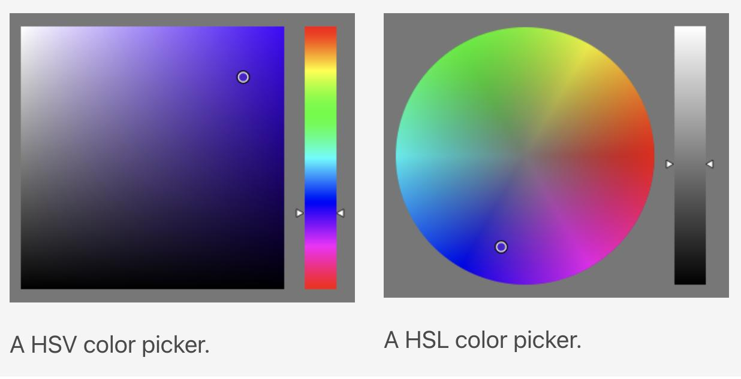
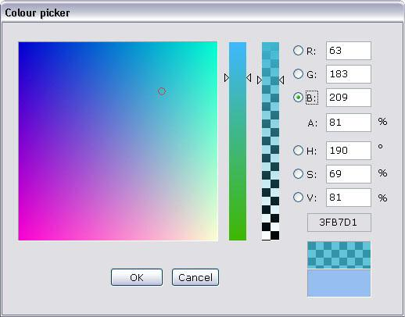
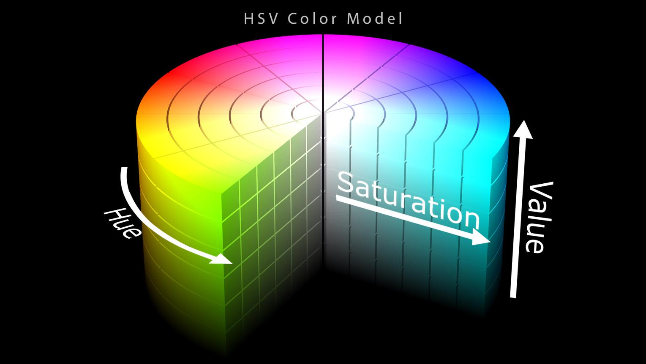

⚙️ How HSV works
# Source: AI Source: Provided by: [Data Path: Persons Table -> ID Column: 1, Name_En Column: Motasem Essam] -> From: [ChatGPT] on [5/2/2026]
- Hue = color on a wheel (0°–360°)
- Saturation = color intensity (0%–100%)
- Value = brightness (0%–100%)

🧠 HSV Examples (Basic + Mixed Colors)
# Source: AI Source: Provided by: [Data Path: Persons Table -> ID Column: 1, Name_En Column: Motasem Essam] -> From: [ChatGPT] on [5/2/2026]
🎯 Basic colors
- Red → HSV(0°, 100%, 100%)
- Green → HSV(120°, 100%, 100%)
- Blue → HSV(240°, 100%, 100%)
🎨 Mixed colors
- Yellow (Red + Green) → HSV(60°, 100%, 100%)
- Cyan (Green + Blue) → HSV(180°, 100%, 100%)
- Magenta (Red + Blue) → HSV(300°, 100%, 100%)
- Orange → HSV(30°, 100%, 100%)
- Purple → HSV(270°, 100%, 80%)

🧑‍💻 Where HSV is used
# Source: AI Source: Provided by: [Data Path: Persons Table -> ID Column: 1, Name_En Column: Motasem Essam] -> From: [ChatGPT] on [5/2/2026]
- 🎮 Game development (lighting, effects)
- 🎨 Image editing tools (Photoshop, GIMP)
- 🖌️ Digital painting apps
- 🎯 Color pickers in design software

🎨 HSL Color Model
# Source: AI Source: Provided by: [Data Path: Persons Table -> ID Column: 1, Name_En Column: Motasem Essam] -> From: [ChatGPT] on [5/2/2026]
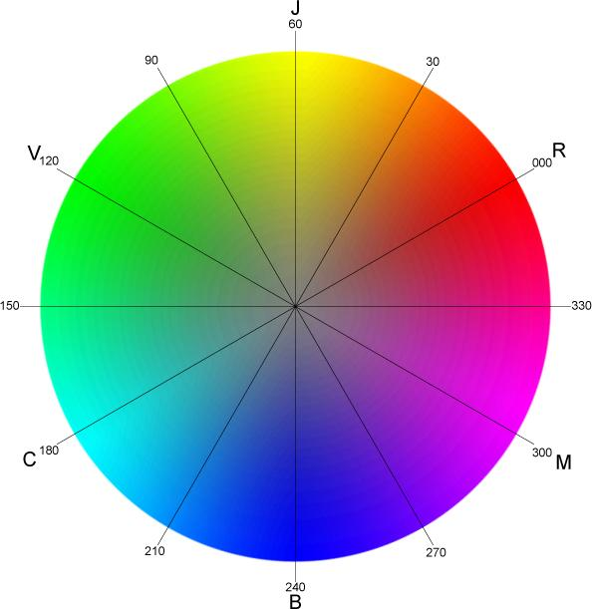
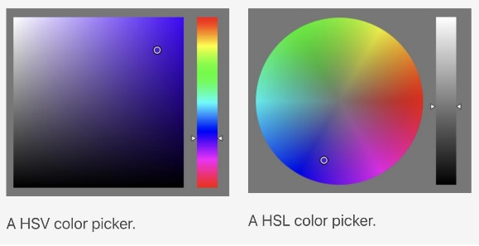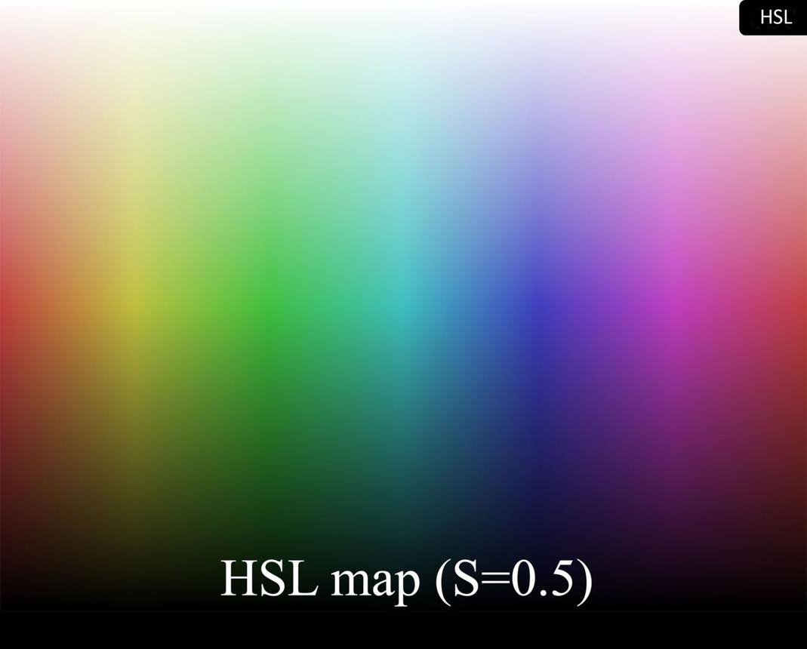

⚙️ How HSL works
# Source: AI Source: Provided by: [Data Path: Persons Table -> ID Column: 1, Name_En Column: Motasem Essam] -> From: [ChatGPT] on [5/2/2026]
- Hue = color position (0°–360°)
- Saturation = color strength (0%–100%)
- Lightness = brightness (0%–100%)

🧠 HSL Examples (Basic + Mixed Colors)
# Source: AI Source: Provided by: [Data Path: Persons Table -> ID Column: 1, Name_En Column: Motasem Essam] -> From: [ChatGPT] on [5/2/2026]
🎯 Basic colors
- Red → HSL(0°, 100%, 50%)
- Green → HSL(120°, 100%, 50%)
- Blue → HSL(240°, 100%, 50%)
🎨 Mixed colors
- Yellow (Red + Green) → HSL(60°, 100%, 50%)
- Cyan (Green + Blue) → HSL(180°, 100%, 50%)
- Magenta (Red + Blue) → HSL(300°, 100%, 50%)
- Orange → HSL(30°, 100%, 50%)
- Pink → HSL(350°, 100%, 80%)
- Light Green → HSL(120°, 100%, 75%)

🧑‍💻 Where HSL is used
# Source: AI Source: Provided by: [Data Path: Persons Table -> ID Column: 1, Name_En Column: Motasem Essam] -> From: [ChatGPT] on [5/2/2026]
- 🌐 Web design (CSS colors in HTML)
- 🎨 UI/UX design (themes, buttons, layouts)
- 🧑‍🎨 Design tools and color palettes
- 📱 App interface customization

🔍 Key Difference
# Source: AI Source: Provided by: [Data Path: Persons Table -> ID Column: 1, Name_En Column: Motasem Essam] -> From: [ChatGPT] on [5/2/2026]
- HSV → brightness controlled by Value (good for artists, editing)
- HSL → brightness controlled by Lightness (good for web design)

🚀 In short:
# Source: AI Source: Provided by: [Data Path: Persons Table -> ID Column: 1, Name_En Column: Motasem Essam] -> From: [ChatGPT] on [5/2/2026]
HSV and HSL are color models that make it easier to create and understand both basic and mixed colors using hue, saturation, and brightness/lightness.

